Spring REST using Spring Boot 3 Assignments
Creating Microservices for account and loan

1. Account Microservice
Project Structure
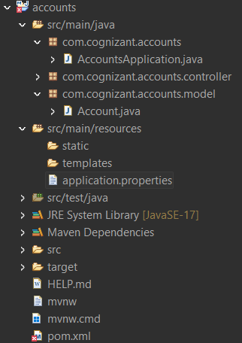

AccountApplication.java
package com.cognizant.accounts;

import org.springframework.boot.SpringApplication;
import org.springframework.boot.autoconfigure.SpringBootApplication;

@SpringBootApplication
public class AccountsApplication {

public static void main(String[] args) {
SpringApplication.run(AccountsApplication.class, args);
}

}

Account.java
package com.cognizant.accounts.model;

public class Account {

private String number;
private String type;
private double balance;

public Account() {
}

public Account(String number, String type, double balance) {
this.number = number;
this.type = type;
this.balance = balance;
}

public String getNumber() {
return number;
}

public void setNumber(String number) {
this.number = number;
}

public String getType() {
return type;
}

public void setType(String type) {
this.type = type;
}

public double getBalance() {
return balance;
}

public void setBalance(double balance) {
this.balance = balance;
}
}

AccountController.java
package com.cognizant.accounts.controller;

import org.springframework.web.bind.annotation.GetMapping;
import org.springframework.web.bind.annotation.PathVariable;
import org.springframework.web.bind.annotation.RestController;

import com.cognizant.accounts.model.Account;

@RestController
public class AccountController {

@GetMapping("/accounts/{number}")
public Account getAccount(@PathVariable String number) {

return new Account(
number,
"savings",
234343
);
}
}

application.properties
spring.application.name=accounts
server.port=8080

Test URL
http://localhost:8080/accounts/00987987973432

Output:
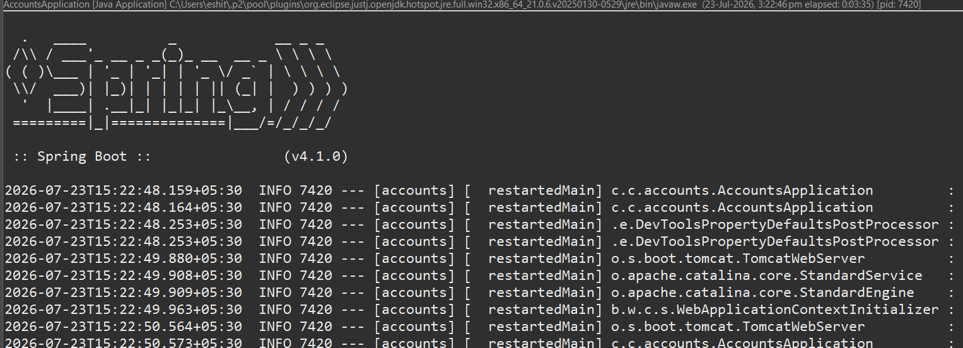
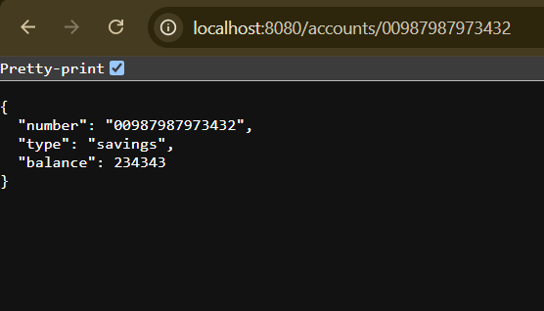

2. Loan Microservice

Project Structure
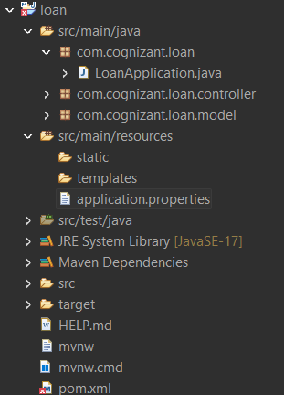

LoanApplication.java
package com.cognizant.loan;

import org.springframework.boot.SpringApplication;
import org.springframework.boot.autoconfigure.SpringBootApplication;

@SpringBootApplication
public class LoanApplication {

public static void main(String[] args) {
SpringApplication.run(LoanApplication.class, args);
}

}

Loan.java
package com.cognizant.loan.model;

public class Loan {

private String number;
private String type;
private double loan;
private double emi;
private int tenure;

public Loan() {
}

public Loan(String number,
String type,
double loan,
double emi,
int tenure) {

this.number = number;
this.type = type;
this.loan = loan;
this.emi = emi;
this.tenure = tenure;
}

public String getNumber() {
return number;
}

public void setNumber(String number) {
this.number = number;
}

public String getType() {
return type;
}

public void setType(String type) {
this.type = type;
}

public double getLoan() {
return loan;
}

public void setLoan(double loan) {
this.loan = loan;
}

public double getEmi() {
return emi;
}

public void setEmi(double emi) {
this.emi = emi;
}

public int getTenure() {
return tenure;
}

public void setTenure(int tenure) {
this.tenure = tenure;
}
}

LoanController.java
package com.cognizant.loan.controller;

import org.springframework.web.bind.annotation.GetMapping;
import org.springframework.web.bind.annotation.PathVariable;
import org.springframework.web.bind.annotation.RestController;

import com.cognizant.loan.model.Loan;

@RestController
public class LoanController {

@GetMapping("/loans/{number}")
public Loan getLoan(@PathVariable String number) {

return new Loan(
number,
"car",
400000,
3258,
18
);
}
}

application.properties
spring.application.name=loan
server.port=8081

Test URL
http://localhost:8081/loans/H00987987972342
Output:
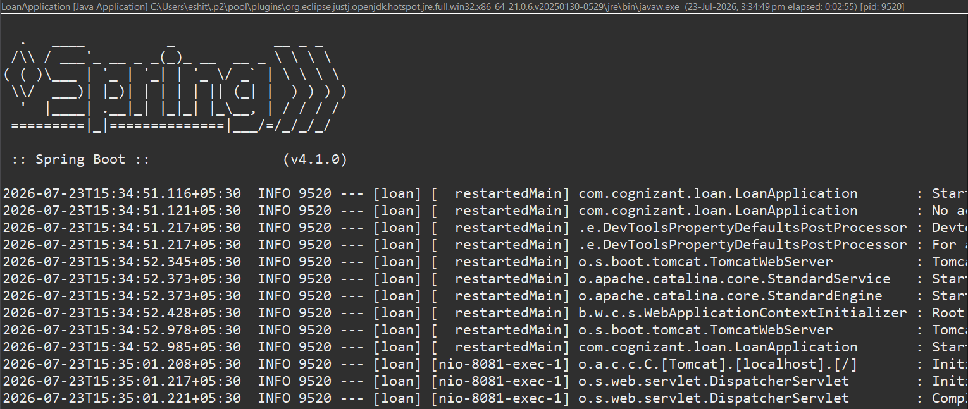
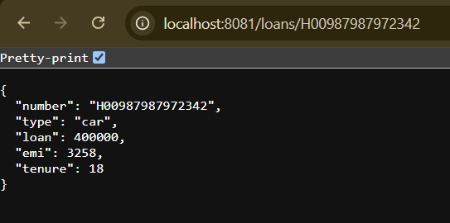

Conclusion
In this assignment, two independent Spring Boot microservices, Account and Loan, were successfully developed. Each microservice exposes its own REST API to return dummy account and loan details without any backend database connectivity. The services were configured to run on different ports (8080 and 8081), demonstrating how multiple microservices can operate independently without port conflicts. This exercise provided a basic understanding of creating, configuring, and running independent RESTful microservices using Spring Boot.

